**Simple Linear Regression with Salary Data**

To perform this regression we use the tool called Gretl and follow the steps listed below.

1. Select the model function from the menu and select the ordinary least squares option. We then select the dependent variables and the regressors(independent variables).

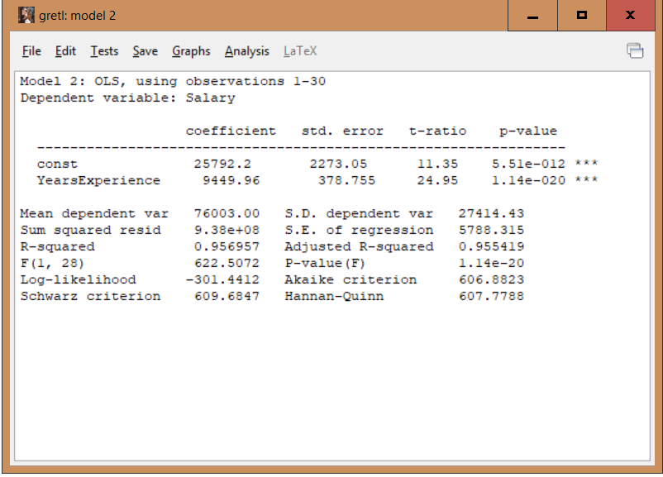

1. We analyse the above model and observe that the coefficient of the constant is 25792 which suggests that the minimum salary for a person with 0 experience is 25792 according to the data. Alspo we note the p-value and see that they are significantly low which is a good sign to suggest that the variable YearsExperience is having an impact on the salary.
2. We forecast the data and check the predicted values for the given experience based on the fitted model. Also we can observe a graph with the fitted vs residual values. Also given in this graph is the 95% confidence interval which shows that the model is accurate to 95%.

